**Star Destroyer Documentation**

**Created by**

Poravee Binhayeearason 6230314421

Supanart Barnsongkit 6230522621

**2110215 Programming Methodology**

**Semester 1 Year 2020**

**Chulalongkorn University**

**Star_Destroyer**

**Introduction**

Star_Destroyer is inspired by arcade game name “Space Invader”. The objective of the game is to have the most score points.

**How to play**

* Use arrow keys to move your rocket.
* Use key ‘X’ to shoot bomb.
* Use key ‘Z’ to shoot laser.
* Use key ‘SPACE’ to shoot normal bullet.
* Defeat invaders and survive to protect our galaxy.

**Title scene**

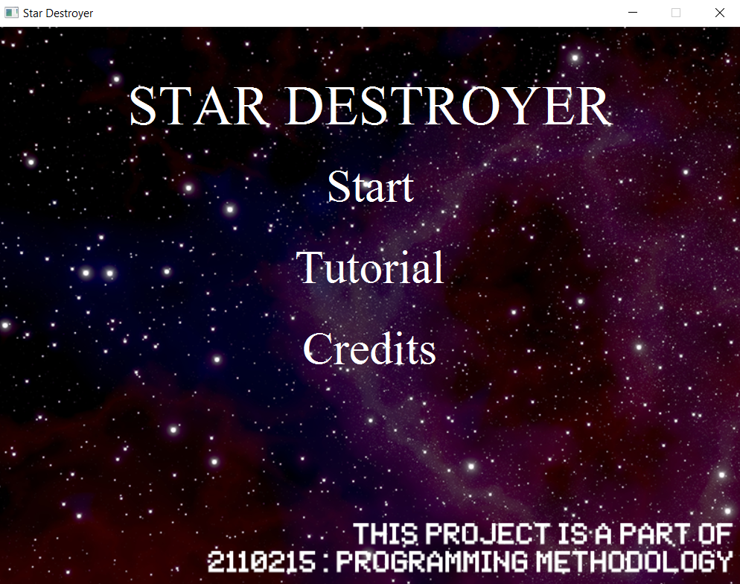

**Tutorial scene**

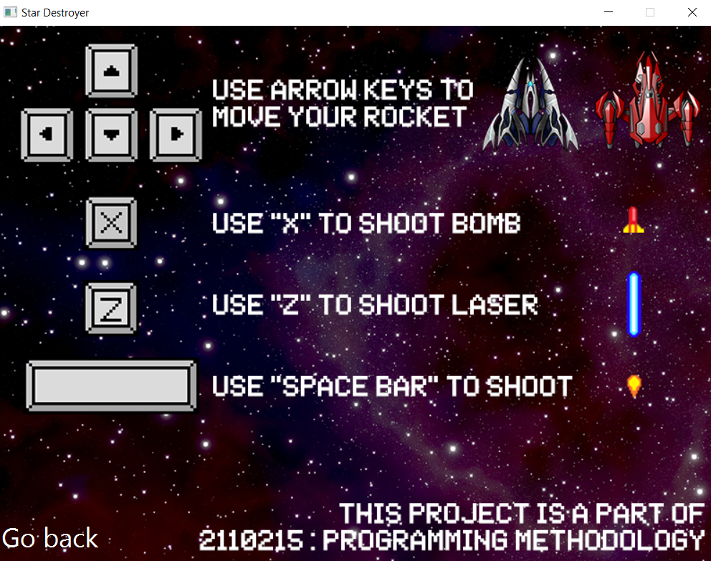

**ChooseRocket scene**

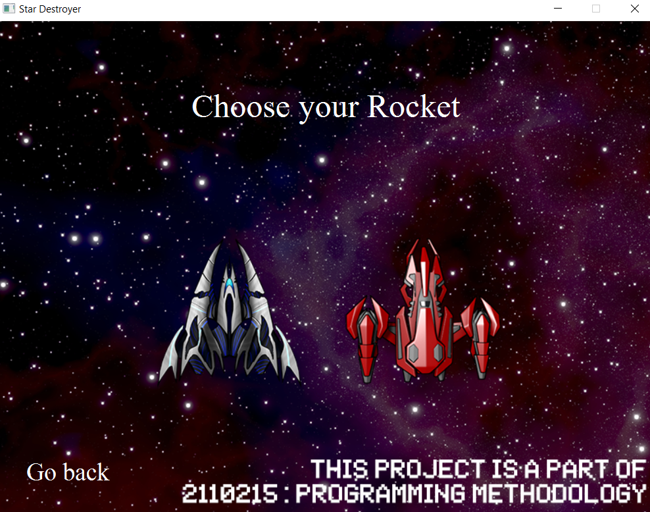

**GameStart scene**

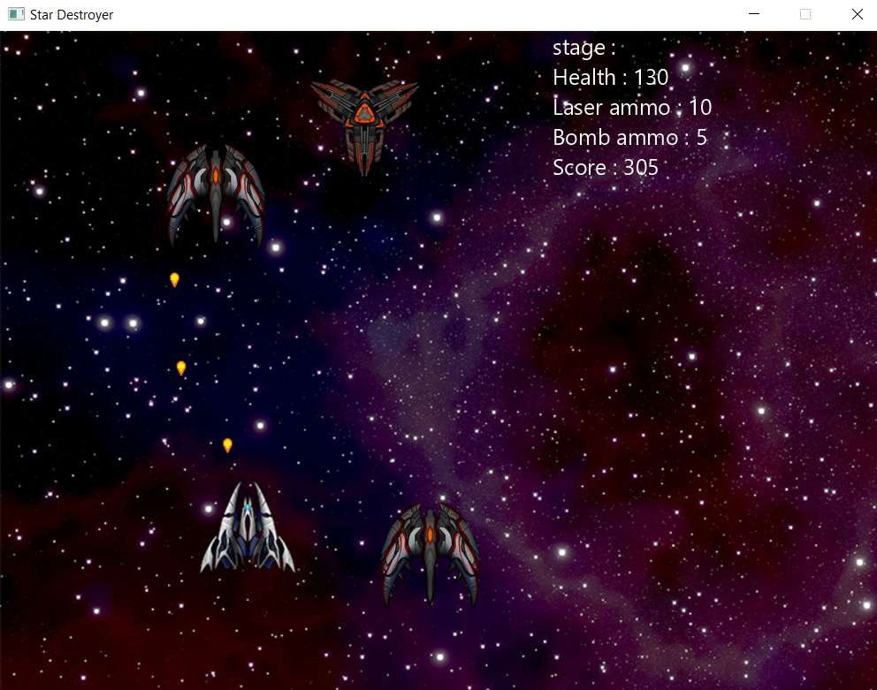

**Class diagram**

**<img>**

**1.Package sprite**

1.1 interface Moveable

1.1.1 Methods

|  |  |
| --- | --- |
| + void moveUp(); | Move the sprite up |
| + void moveDown(); | Move the sprite down |
| + void moveLeft(); | Move the sprite left |
| + void moveRight(); | Move the sprite right |

1.2 interface Hittable

1.1.2 Methods

|  |  |
| --- | --- |
| + void hit(); | To do something depending on what the object is |

1.3 interface Updatable

1.1.3 Methods

|  |  |
| --- | --- |
| + void update(); | To update the sprite |

1.4 interface Renderable

1.1.4 Methods

|  |  |
| --- | --- |
| + Rectangle2D getBoundary(); | To get object boundary |
| + void render(GraphicsContext gc); | To draw object in scene |
| + Boolean intersects(Sprite s); | To check the sprite is intersected with another sprite |

1.5 class Sprite implements Renderable

1.5.1 Fields

|  |  |
| --- | --- |
| # Image image; | Image of the sprite |
| # double positionX; | Position (X-axis) of the sprite |
| # double positionY; | Position (Y-axis) of the sprite |
| # double width; | Sprite width |
| # double height; | Sprite height |

1.5.2 Constructors

|  |  |
| --- | --- |
| + void Sprite(double positionX, double positionY, double width, double height | Set position and size |

1.5.3 Methods

|  |  |
| --- | --- |
| + void render(GraphicsContext gc); | Draw image |
| + void render(GraphicContext gc, double width, double height); | Draw image and fix size |
| + Rectangle2D getBoundary(); | return object boundary |
| + Boolean intersects(Sprite s); | To check the sprite is intersected with another sprite |
| Getters & Setters | To get and set field |

1.6 class Bullet extends Sprite implements Moveable, Hittable, Updatable

1.6.1 Fields

|  |  |
| --- | --- |
| + final int BULLET_SPEEDX; | BULLET_SPEEDX = 0 |
| + final int BULLET_SPEEDY; | BULLET_SPEEDX = 10 |
| + final int BULLET_WIDTH; | BULLET_WIDTH = 10 |
| + final int BULLET_HEIGHT; | BULLET_HEIGHT = 10 |
| - int bulletDamage; | Damage of the bullet |
| - int speedX; | Speed (X-axis) of bullet |
| - int speedY; | Speed (Y-axis) of bullet |
| - Boolean isConsumed; | To consume (disappear) when hit minion (expects LaserBullet) |

1.6.2 Constructor

|  |  |
| --- | --- |
| + Bullet(Rocket rocket); | - Construct super class with default values (0)  - set speed  - set isConsumed to false |

1.6.3 Methods

|  |  |
| --- | --- |
| + void update(); | moveUp(); |
| + void hit(); | Set isConsumed to true |
| + void moveUp(); | position -= speedY; |
| + void moveDown(); | Do nothing |
| + void moveLeft(); | Do nothing |
| + void moveRight(); | Do nothing |
| Getters & Setters | To get and set field |

1.7 class PointBullet extends Bullet

1.7.1 Fields

|  |  |
| --- | --- |
| + final int POINT_DELAYTIME; | POINT_DELAYTIME = 50 |
| + final int POINT_DAMAGE; | POINT_DAMAGE = 5 |

1.7.2 Constructors

|  |  |
| --- | --- |
| + PointBullet(Rocket rocket); | - Construct super class with rocket  - set damage  - set image  - set size  - set position at rocket position |

1.8 class LaserBullet extends Bullet

1.8.1 Fields

|  |  |
| --- | --- |
| + final int LASER_DELAYTIME; | LASER_DELAYTIME = 3000 |
| + final int LASER_DAMAGE; | LASER_DAMAGE = 40 |

1.8.2 Constructors

|  |  |
| --- | --- |
| + LaserBullet(Rocket rocket); | - Construct super class with rocket  - set damage  - set image  - set size  - set position at rocket position |

1.9 class BombBullet extends Bullet

1.9.1 Fields

|  |  |
| --- | --- |
| + final int BOMB_DELAYTIME; | BOMB_DELAYTIME = 3000 |
| + final int BOMB_DAMAGE; | BOMB_DAMAGE = 50 |

1.9.2 Constructors

|  |  |
| --- | --- |
| + BombBullet(Rocket rocket); | - Construct super class with rocket  - set damage  - set image  - set size  - set position at rocket position |

1.10 class BombAnimation extends Sprite

1.11 class Storage

1.11.1 Fields

|  |  |
| --- | --- |
| - int bombCapacity | The amount of Bomb Bullets when start game |
| - int laserCapacity | The amount of Laser Bullets when start game |
| - int bombRemain | Current quantity of Bomb Bullets |
| - int laserRemain | Current quantity of Laser Bullets |

1.11.2 Constructors

|  |  |
| --- | --- |
| + Storage(int bombCapacity, int laserCapacity); | - set bombCapacity, laserCapacity  - set bombRemain, laserRemain  (equals their capacities) |

1.11.3 Methods

|  |  |
| --- | --- |
| + boolean hasBombBullet(); | To check bombRemain > 0 |
| + void consumeBombBullet(); | Decrease bombRemain by 1 |
| + boolean hasLaserBullet(); | To check laserRemain > 0 |
| + void consumeLaserBullet(); | Decrease laserRemain by 1 |
| Getters & Setters | To get and set field |

1.12 class Rocket extends Sprite implements Moveable, Hittable, Updatable

1.12.1 Fields

|  |  |
| --- | --- |
| + final int ROCKET_WIDTH; | ROCKET_WIDTH = 100 |
| + final int ROCKET_HEIGHT; | ROCKET_HEIGHT = 100 |
| - String name; | Name of the rocket |
| - Storage storage; | Rocket storage (contains bullets) |
| - int maxHp; | Max Hp of the rocket |
| - int hp; | Current Hp of the rocket |
| - double speedX; | Rocket speed (X-axis) when move |
| - double speedY; | Rocket speed (Y-axis) when move |
| - BulletManager bulletManager; | Bullet manager of the rocket |
| - int bodyDamage; | Damage the entity get when hit the rocket |
| - int score; | Rocket score |

1.12.2 Constructors

|  |  |
| --- | --- |
| + Rocket(String name, Storage storage, int maxHp, double speedX, double speedY, int bodyDamage); | - Construct super class with default values (0)  - set name and bodyDamage  - set maxHp, hp by maxHp value  - set speed (X and Y)  - set score to 0  - set bulletManager (use bulletManager constructor) |

1.12.3 Methods

|  |  |
| --- | --- |
| + void shoot(); | Add pointBullet in bulletManager |
| + void laser(); | Add laserBullet in buleltManager |
| + void bomb(); | Add bombBullet in bulletManager |
| + void addScore(int score); | Increase current score |
| + void decreaseHp(int damage); | Decrease current Hp by damage  (current Hp is more or equal 0) |
| + Boolean isDead(); | To check current Hp is 0 |
| + void moveUp(); | positionY -= speedY; |
| + void moveDown(); | positionY += speedY; |
| + void moveLeft(); | positionX -= speedX; |
| + void moveRight(); | positionX += speedX; |
| + void move(); | Check with Controller class and GameStartScene.GAMELAYER_HEIGHT and WIDTH to move (use interface Moveable methods) |
| + void updatePointShoot(); | If Controller.isShooting() and not isPointDelay(); then start thread to  - shoot();  - play sound effect “gunsound.wav”  - set pointDelay to true  - thread sleep(POINT_DELAYTIME)  - set pointDelay to false |

|  |  |
| --- | --- |
| + void updateLaserShoot(); | If Controller.isShootingLaser() and not isLaserDelay(); then start thread to  - laser();  - play sound effect “lasersound.wav”  - set laserDelay to true  - thread sleep(LASER_DELAYTIME)  - set laserDelay to false |
| + void updateBombShoot(); | If Controller.isShootingBomb() and not isBombrDelay(); then start thread to  - bomb();  - play sound effect “bombsound.wav”  - set bombDelay to true  - thread sleep(BOMB_DELAYTIME)  - set bombDelay to false |
| + void update(); | Do nothing |
| + void update(GraphicContext gc); | - move();  - updatePointShoot();  - updateLaserShoot();  - updateBombShoot();  - bulletManager.update(gc);  - render(gc); |
| + void hit(); | Do nothing |
| + void hit(Entity entity); | Decrease Hp by entity’s damage |
| Getters & Setters | To get and set field |

1.13 class RocketTypeA extends Rocket

1.13.1 Fields

|  |  |
| --- | --- |
| - final String TYPE_A_NAME; | TYPE_A_NAME = “Hawk” |
| - final int TYPE_A_BOMBCAP; | TYPE_A_BOMBCAP = 5 |
| - final int TYPE_A_LASERCAP; | TYPE_A_LASERCAP = 10 |
| - final Storage TYPE_A_STORAGE; | TYPE_A_STORAGE = new Storage(TYPE_A_BOMBCAP, TYPE_A_LASERCAP); |
| - final int TYPE_A_MAXHP; | TYPE_A_MAXHP = 250 |
| - final double TYPE_A_SPEEDX; | TYPE_A_SPEEDX = 6 |
| - final double TYPE_A_SPEEDY; | TYPE_A _SPEEDY = 6 |
| -final int TYPE_A_BODYDAMAGE; | TYPE_A_BODYDAMAGE = 20 |

1.13.2 Constructors

|  |  |
| --- | --- |
| + RocketTypeA(); | - Construct super class with its constants  - set image  - set width and height  - set positionX to GAMELAYER_WIDTH/2 – this.getWidth()  - set positionY to GAMELAYER_HEIGHT – this.getHeight() |

1.14 class RocketTypeB extends Rocket

1.14.1 Fields

|  |  |
| --- | --- |
| - final String TYPE_B_NAME; | TYPE_B_NAME = “Tank” |
| - final int TYPE_B_BOMBCAP; | TYPE_B_BOMBCAP = 10 |
| - final int TYPE_B_LASERCAP; | TYPE_B_LASERCAP = 15 |
| - final Storage TYPE_B_STORAGE; | TYPE_B_STORAGE = new Storage(TYPE_B_BOMBCAP, TYPE_B_LASERCAP); |
| - final int TYPE_B_MAXHP; | TYPE_B_MAXHP = 350 |
| - final double TYPE_B_SPEEDX; | TYPE_B_SPEEDX = 4 |
| - final double TYPE_B_SPEEDY; | TYPE_B _SPEEDY = 4 |
| -final int TYPE_B_BODYDAMAGE; | TYPE_B_BODYDAMAGE = 30 |

1.14.2 Constructors

|  |  |
| --- | --- |
| + RocketTypeB(); | - Construct super class with its constants  - set image  - set width and height  - set positionX to GAMELAYER_WIDTH/2 – this.getWidth()  - set positionY to GAMELAYER_HEIGHT – this.getHeight() |

1.15 class Entity extends Sprite implements Moveable, Hittable, Updatable

1.15.1 Fields

|  |  |
| --- | --- |
| + final int ENTITY_WIDTH; | ENTITY_WIDTH = 100 |
| + final int ENTITY_HEIGHT; | ENTITY_HEIGHT = 100 |
| - int maxHp; | Max Hp of the entity |
| - int hp; | Current Hp of the entity |
| - double speedX; | Speed (X-axis) of the entity |
| - double speedY; | Speed (Y-axis) of the entity |
| - Boolean isMovingLeftDirection; | To check direction of the entity (X-axis) |

1.15.2 Constructors

|  |  |
| --- | --- |
| + Entity(int maxHp); | - Construct super class with default values (0)  - set maxHp  - set current hp  - set moveLeftDirection (use randomDirection()) |

1.15.3 Methods

|  |  |
| --- | --- |
| + Boolean randomDirection(); | Return new Random().nextBoolean(); |
| + void looted(Rocket rocket); | Add rocket score (score is random int from 1 to 10) |
| + void decreaseHp(int damage); | Decrease current Hp by damage  (current Hp is more or equal 0) |
| + Boolean isDead(); | To check current hp equals 0 |
| + isBorderCollision(); | To check positionX is between 0 and GAMELAYER_WIDTH – this.getWidth() |

|  |  |
| --- | --- |
| + void moveUp(); | Do nothing |
| + void moveDown(); | positionY += speedY |
| + void moveLeft(); | positionX -= speedX |
| + void moveRight(); | positionX += speedX |
| + void checkDirectionAfterMove(); | If isBorderCollision then switch isMovingLeftDirection (true to false, false to true) |
| + void update(); | - moveDown();  - if isMovingLeftDirection then moveLeft() ,otherwise moveRight()  - checkDirectionAfterMove(); |
| + void hit(); | Do nothing |
| + void hit(Rocket rocket); | Decrease Hp by rocket’s bodyDamage |
| + void hit(Bullet bullet); | Decrease Hp by bullet’s damage |
| *+ int getDamage();* | To be overrided in Minion class |
| Getters & Setters | To get and set field |

1.16 class Minion extends Entity

1.16.1 Fields

|  |  |
| --- | --- |
| - final int MINION_MAXHP; | MINION_MAXHP = 20 |
| - final double MINION_SPEEDX_RANGE; | MINION_SPEEDX_RANGE = 3; |
| - final double MINION_SPEEDY_RANGE; | MINION_SPEEDY_RANGE = 3; |
| - final int MINION_DAMAGE; | MINION_DAMAGE = 10; |
| - int type; | Type of Minion (used to indicate minion’s color) |

1.16.2 Constructors

|  |  |
| --- | --- |
| + Minion(); | - Construct super class with its constants  - randomType();  - set speedX (use randomMinionSpeedX())  - set speedY (use randomMinionSpeedY())  - if type is 1 then set image to green minion else if type is 2 then set image to yellow minion else if type is 3 then set image to red minion  - set positionX (use randomPositionX()) |

1.16.3 Methods

|  |  |
| --- | --- |
| + int getDamage(); | Return MINION_DAMAGE (Override method from Entity class) |
| + double randomPositionX(); | Return random double from 0 to GAMELAYER_WIDTH – getWidth() |
| + void randomType(); | Set type to random int from 1 to 3 |
| + double randomMinionSpeedX(); | Return new Random().nextDouble() * MINION_SPEEDX_RANGE + 1; |
| + double randomMinionSpeedY(); | Return new Random().nextDouble() * MINION_SPEEDY_RANGE + 1; |
| + int getType(); | Return type |

**2.Package logic**

2.1 class Controller

2.1.1 Fields

|  |  |
| --- | --- |
| - boolean isMoveLeft; | isMoveLeft = false |
| - boolean isMoveRight; | isMoveRight = false |
| - boolean isMoveUp; | isMoveUp = false |
| - boolean isMoveDown; | isMoveDown = false |
| - boolean isShooting; | isShooting = false |
| - boolean isShootingLaser; | isShootingLaser = false |
| - boolean isShootingBomb; | isShootingBomb = false |
| - boolean pointDelay; | pointDelay = false |
| - boolean laserDelay; | laserDelay = false |
| - boolean bombDelay; | bombDelay = false |

2.1.2 Methods

|  |  |
| --- | --- |
| Getters & Setters | To get and set fields |

2.2 class BulletManager

2.2.1 Fields

|  |  |
| --- | --- |
| - Rocket rocket; | Choosed rocket in game |
| - ArrayList<Bullet> bullets | Bullets = new ArrayList<>(); |

2.2.2 Constructors

|  |  |
| --- | --- |
| + BulletManager(Rocket rocket); | Set rocket |

2.2.3 Methods

|  |  |
| --- | --- |
| + void addBullet(); | Add new pointBullet in bullets |
| + void addLaserBullet(); | Add new lasetBullet in bullets |
| + void addBombBullet(); | Add new bombBullet in bullets |
| + void update(GraphicContext gc); | - Initailize ArrayList<Integer> toRemove  - check all bullet in bullets if its position less than 0 then add bullet index to toRemove, otherwise update and render it  - sort toRemove (reverseOrder)  - remove bullet in bullets by its index for all bullet in toRemove |
| + void clear(); | Remove all bullet in bullets (use clear()) |
| Getters & Setters | To get and set fields |

2.3 class MinionManager

2.3.1 Fields

|  |  |
| --- | --- |
| - ArrayList<Entity> minions | Minions = new ArrayList<>(); |

2.3.2 Constructors

|  |  |
| --- | --- |
| + MinionManager(); | Calls addMinion() 3 times |

2.3.3 Methods

|  |  |
| --- | --- |
| + void addMinion(); | Add minion in minions |
| + void update(BulletManager bulletmanager, GraphicContext gc, Rocket rocket); | - Initailize ArrayList<Interger> toRemoveBullets and toRemoveMinions  - int more = 0  - for all minion in minions  + update and render  + if position is out of scene then add to toRemoveMinions  + if minion intersects rocket then call hit both sprites  + check with all bullet in bullet if minion intersects bullet then call hit both sprites (except laserBullet) and check if bullet is Consumed then add to toRemoveBullets  - if minion is dead then add to toRemoveMinions  - Initailize HashSet<Integer> to remove each minion in minions and bullet in bullets  - when minion removed, add more with 1  - addMinion according to more times |
| + void clear | Clear minions |

2.4 class AudioManager

2.4.1 Fields

|  |  |
| --- | --- |
| - final double GLOBAL_VOLUME; | GLOBAL_VOLUME = 0.5 |
| - MediaPlayer bgmPlayer | The object to play BGM |

2.4.2 Methods

|  |  |
| --- | --- |
| - Boolean isBGMPlaying(); | To check bgmPlayer is not null |
| + Media getCurrentBGM(); | To get current BGM |
| + void playBGM(Media bgm, double localVolume, Boolean isLoop); | - if bgm is null then stopBGM  - if bgm is not equals current BGM then play bgm instead |
| + void stopBGM(); | - if BGM is playing then stop and set to null |

2.5 class ResourceManager

2.5.1 Fields

|  |  |
| --- | --- |
| + TitleResource title; | The subclass that contains resource for title scene |
| + SelectRocketResource selectRocket; | The subclass that contains resource for selectRocket scene |
| + GameStartResource gameStart; | The subclass that contains resource for gameStart scene |
| + TutorialResource tutorial; | The subclass that contains resource for tutorial scene |
| + CreditsResource credits; | The subclass that contains resource for credits scene |
| + LosingResource losing; | The subclass that contains resource for losing scene |
| + SoundtrackResource bgm; | The subclass that contains sound for all scenes |

2.5.2 Methods

|  |  |
| --- | --- |
| + void loadResources( SceneManager.State sceneState); | Initailize 1 in 6 subclasses resources followed by sceneState (if catch exception then throws new ResourceNotFoundException (e.getMessage()) |
| + void clearResources(SceneManager.State sceneState); | Set 1 in 6 subclasses resources to null followed by sceneState |
| + void loadAllSharedResources(); | If bgm is null then set to new SoundtrackResource(); |
| + Image readImg(String filename); | return new Image(ClassLoader.getSystemResource(filename).toString()); |
| + Media readMedia(String filename); | return new Image(ClassLoader.getSystemResource(filename).toString()); |
| + AudioClip readAudioClip(String filename); | return new AudioClip(ClassLoader.getSystemResource(filename).toString()); |

2.6 class SceneManager

2.6.1 Fields

|  |  |
| --- | --- |
| + final int WINDOW_WIDTH ; | WINDOW_WIDTH = 800 |
| + final int WINDOW_HEIGHT ; | WINDOW_HEIGHT = 600 |
| - Stage window; | Game Stage |
| - GameScene currentScene; | Game current scene |
| - State sceneState; | Game current state |
| + enum State; | {TITLE, SELECTROCKET, PLAYING, TUTORIAL, CREDITS, LOSING} |

2.6.2 Methods

|  |  |
| --- | --- |
| + void init(Stage stage, State sceneState) throws GameException; | - set window to stage  - load all shared resources  - set sceneStage  - set current scene from sceneStage  - set scene in window to currentScene |
| + Scene getCurrentScene(); | Return currentScene |
| + State getSceneState; | Return sceneState |
| + void changesSceneState(State sceneState) throws GameException; | - if window is null then throw new SceneChangingException ("At SceneManager, window is null");  - otherwise, set sceneState, set scene on window and show |
| + void setCurrentSceneFromSceneState (State sceneState) throws GameException; | - set currentScene to null  - load resources and set currentScene to 1 in 6 scene followed by sceneState |
| + void update(); | Update currentScene if it is not null |

**3.Package exception**

3.1 class GameException

3.1.1 Fields

|  |  |
| --- | --- |
| - final long serialVersionUID; | serialVersionUID = -2048416760537782547L |

3.1.2 Constuctors

|  |  |
| --- | --- |
| + GameException(); | Construct super class |
| + GameException(String message); | Construct super class with message |

3.1.3 Methods

|  |  |
| --- | --- |
| + void print(); | To print exception |

3.2 class ResourceNotFoundException

3.1.1 Fields

|  |  |
| --- | --- |
| - final long serialVersionUID; | serialVersionUID = 5261600905049703426L |
| - String resource; | The resource that not found |

3.1.2 Constuctors

|  |  |
| --- | --- |
| + ResourceNotFoundException (); | Construct super class |
| + ResourceNotFoundException (String resource); | Construct super class and set resource |
| + ResourceNotFoundException (String resource, String message); | Construct super class with message and set resource |

3.1.3 Methods

|  |  |
| --- | --- |
| + void print() | To print exception |

3.3 class SceneChangingException

3.1.1 Fields

|  |  |
| --- | --- |
| - final long serialVersionUID; | serialVersionUID = -9107197163021617917L |
| # SceneManager.State prev; | Previous stage |
| # SceneManager.State next; | Next stage |

3.1.2 Constuctors

|  |  |
| --- | --- |
| + SceneChangingException () | Construct super class and set prev and next to null |
| + SceneChangingException (String message) | Construct super class with message and set prev and next to null |
| + SceneChangingException (SceneManager.State prev, SceneManager.State next) | Construct super class and set prev and next |
| + SceneChangingException(String message, SceneManager.State prev, SceneManager.State next) | Construct super class with message and set prev and next |

3.1.3 Methods

|  |  |
| --- | --- |
| + void print() | To print exception |

**4.Package gui**

**5.Package application**